names:

Batoul Alhasani 2118180

Abdelrahman yaseen 2175578

Khalid Amairi 2110971

Source Code

By using GitHub, we are going to create our own project repository and a team. The team members will be given the right to modify the project repository. Any team member can commit by sending pull request through a branch, and then it can be tested and merged by the master.

Tests (code)

Everything about testing will be kept under 'Test' folder in master branch

Document / file / binary

For documentation, we will use README files and Wikis which help to present information and explanation about our project in a useful way.

Reporting/Notifications Scripts

Git provides a method to send email notification to a list of email addresses by the remote git server after every push from the client. The subject contains a prefix, the repository name, the branch name and the last commit message. The body of the email contains a summary of the changes and the commit log.

Version tree

Displays changes in a repository or a selected set of commits. This includes visualizing the commit graph, showing information related to each commit, and the files in the trees of each revision.

In git we will be able to get the version tree using “gitk” command which allow us to reach the version tree of our project showing the graph of the tree including the changing in each commit. (example in figure 1)

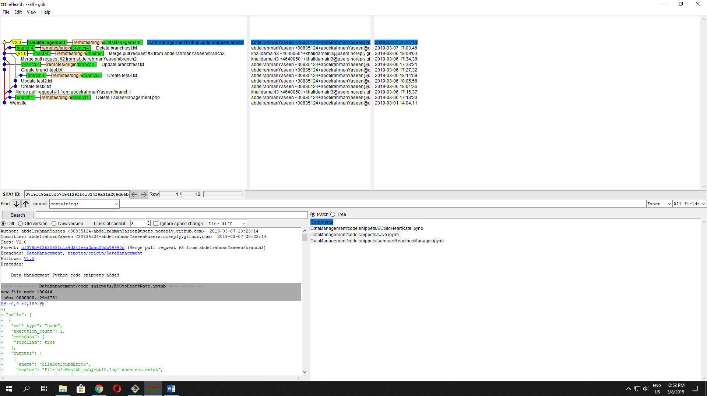

Figure 1

Log /history

Git allows us to look back to the previous commits that have been done. So we can reach the code history in case of unexpected mistake. This can be done using git log command. (example in figure 2)

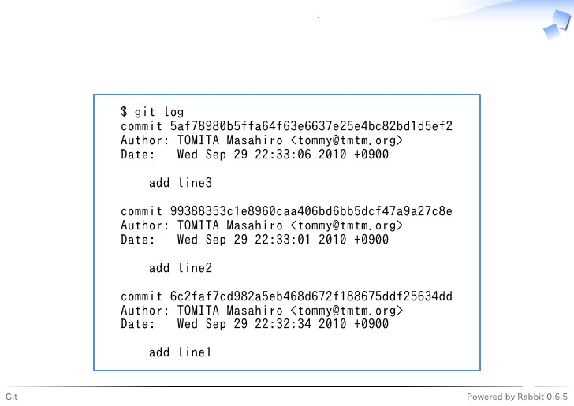

Figure 2

<https://github.com/collab-uniba/socialcde4eclipse/wiki/How-to-setup-a-GitHub-organization,-project-and-team>

<https://code.tutsplus.com/articles/team-collaboration-with-github--net-29876>

<https://github.com/marketplace/testquality>

<https://guides.github.com/features/wikis/>